**LAB 2 – Special Signals**

# Objectives

* Understand degradation of a digital signal as it passes through a system
* Use step and pulse signal inputs to measure system response
* Investigate sine wave distortion and cutoff
* Construct a digital detector

# Background

Bandwidth is a term that has been in the engineering vocabulary for many decades. Its usage has extended over time, especially in the context of digital systems. It has become commonplace now to mean information transfer rate, and all Internet users know that broadband stands for fast, and better. There are highly competitive markets demanding top performance – ever higher speed whilst maintaining a low probability of corruption. However, as speed is increased, obstacles emerge in the form of noise, interference and signal distortion. At the destination these limitations become digital errors, resulting in pixelated images, and audio breaking up.

The most important consideration affecting the speed of a digital signal is the switching process to produce a change of state. The switching time can never be instantaneous in a physical system because of energy storage in electronic circuitry, cabling and connecting hardware. This energy lingers in stray capacitance and inductance that cannot be completely eliminated in wiring and in electronic components. The effect is just like inertia in a mechanical system.

In Part A we investigate how digital signals are distorted when a system's response is affected by inertia. In Parts B and C we use a step and an impulse input, respectively, to measure system response. In Part 4 we introduce the sinewave, and study the phenomena of clipping.

# New Modules

* AUDIO OSCILLATOR
* SEQUENCE GENERATOR
* BASEBAND CHANNEL FILTERS
* UTILITIES

# Part A – Digital Pulse Sequence A.1 – The AUDIO OSCILLATOR

The AUDIO OSCILLATOR provides a sinusoidal output tunable from 300 Hz to 10 kHz (typical audio frequency range). It can also provide a digital output signal by converting the sine wave into a square wave. Note that this digital signal is referred to as a “TTL Signal”, referring to the transistor-transistor logic source of such a signal.

Fig 2 The oscillator is connected to the

frequency counter and the scope.

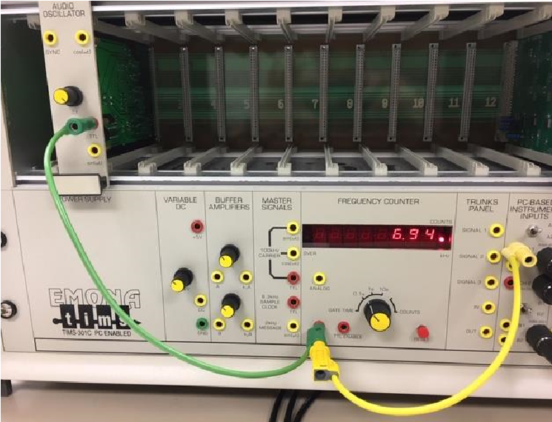

Fig 1 The AUDIO OSCILLATOR module

shown inserted into

Slot 2 of the TIMS rack.

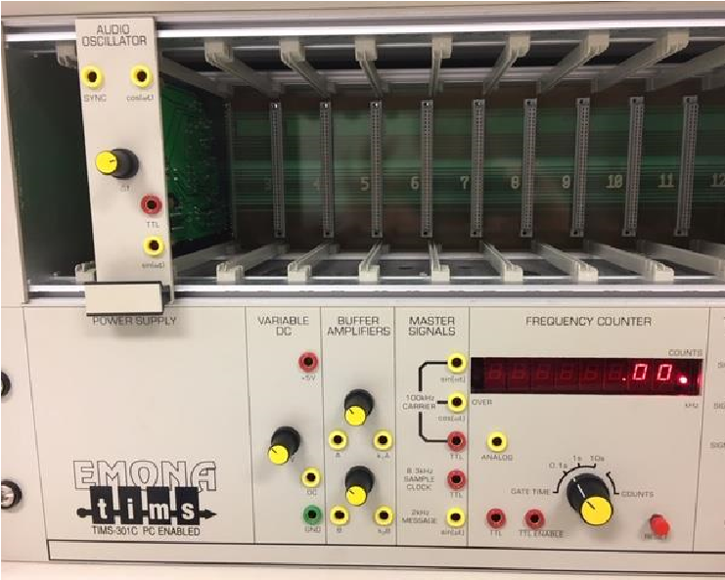

Fig 3 Single Shot Triggering used to

display oscillator output.

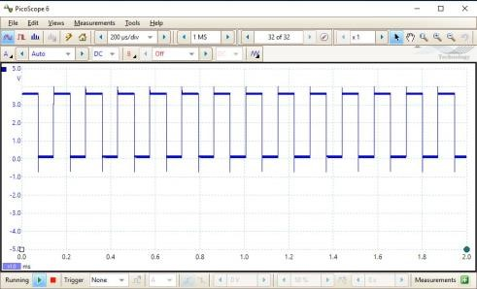

1. Insert the AUDIO OSCILLATOR module into the TIMS rack (shown here in slot 2 of Figure 1).

1. The AUDIO OSCILLATOR output can be measured by connecting it to the frequency counter, and can be viewed by connecting it to the PicoScope.

* Connect the AUDIO OSCILLATOR TTL output to the TTL input of the FREQUENCY COUNTER.
* Also connect the AUDIO OSCILLATOR TTL output to Scope ChA. See Figure 2.
* The value on the FREQUENCY COUNTER is varied by adjusting the f knob on the AUDIO OSCILLATOR. Here it is 6.94k counts per second. For convenience, we will call this “6.94 kHz”.

*Note: Technically a Hz is a cycle per second, referring to sinusoids, not count per second as we use it here. We will consider a kHz to also represent 1000 clock cycles per second*.

3. Turn on the PicoScope

* Set the time scale to 200us/div. Note that the signal jumps around a lot. For triggering, select “single” that will take a freeze frame shot of the signal. This is referred to as “Single Shot Triggering”. See Figure 3.
* Turn the triggering off again (Trigger = None) and also press the green triangle to get the scope running again.

Fig 4



f knob adjustment achieves a 1 kHz signal seen on the counter and on the scope display.

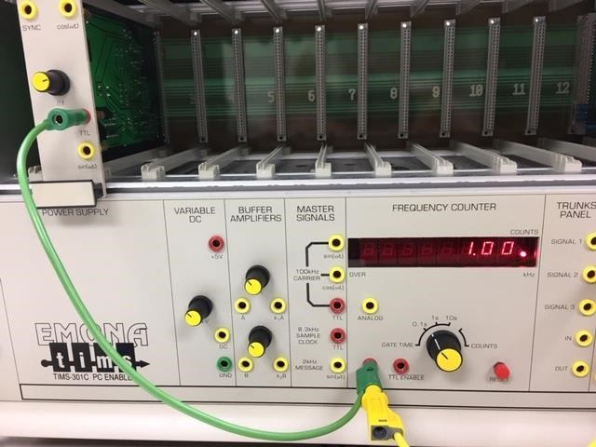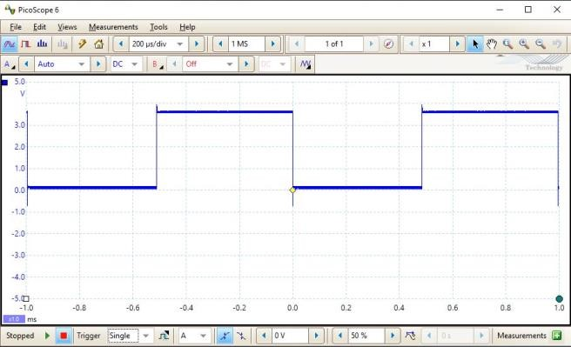

1. Adjust the AUDIO OSCILLATOR’s f knob to achieve close to 1kHz on the counter. On the scope, perform single shot triggering to see what the clock signal looks like. See Figure 4.

1. Let’s try out some useful tools on the upper right of the PicoScope window: the arrow, hand, and magnifying glass icons. See Figure 5a.

* Figure 5b shows the cursor location pop up when the arrow is clicked on the trace at a lower transition point.
* In Figure 5c, the “zoom window” magnifying glass does what you would expect. You can now use the arrow icon to more precisely read points on the scope.
* Measure the duration of one pulse width and one clock cycle and record it here:

Pulse Width = 480.0 µs Clock cycle = 1.006 ms

*Note: the usual way to measure pulse width would be between the middles of the transitions. Here, this should correspond to half of a clock cycle.*

(

a

)

(

b) (c

)

Fig 5 Employ PicoSco

pe tools to accurately determine the cycle duration

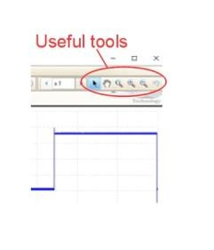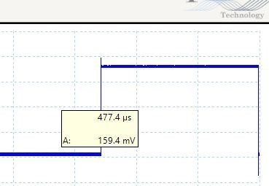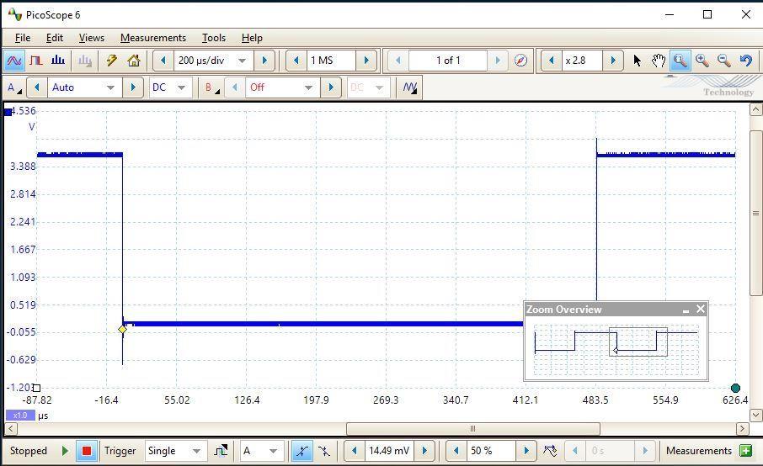

# A.2 – The SEQUENCE GENERATOR

Fig 6 SEQUENCE GENERATOR module is

shown inserted into Slot 4. The oscillator’s

TTL clock output is connected to the

generator’s input.

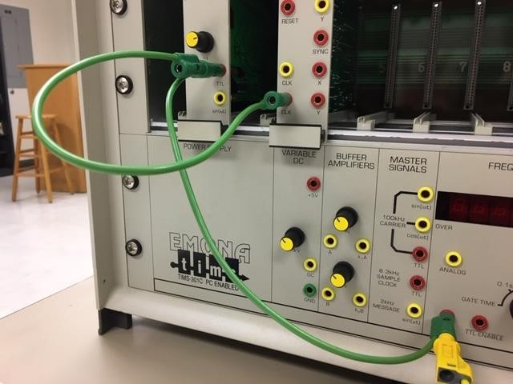

Using a common external clock signal, the SEQUENCE GENERATOR outputs two independent pseudorandom sequences **X** and **Y**. The **X** and **Y** sequences are available as either standard digital output (TTL output uses the red X and Y) or analog output.

1. Insert the SEQUENCE GENERATOR module into the TIMS rack (shown here in slot 4 of Figure 6).

1. Referring to Figure 7a, connect the AUDIO OSCILLATOR TTL clock signal to:

* the SEQUENCE GENERATOR’s red clock input (green lead)
* the FREQUENCY COUNTER (green lead)
* Scope ChA (yellow lead).

1. Connect the SEQUENCE GENERATOR’s red X output to channel B for the scope. See Figure 7a (blue lead).

(

a

)

(

b

)

Fig 7 (a) SEQUENCE GENERATOR connections

and (b) the

clock and digital signals displayed

on the scope

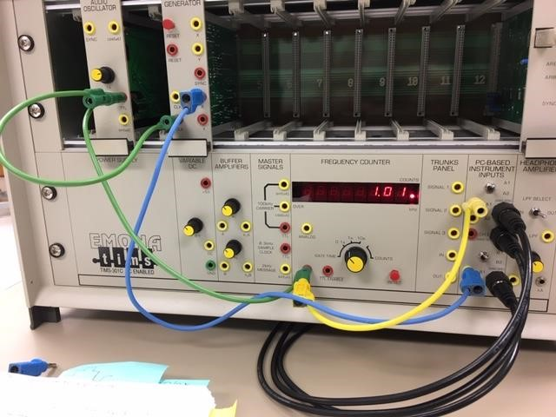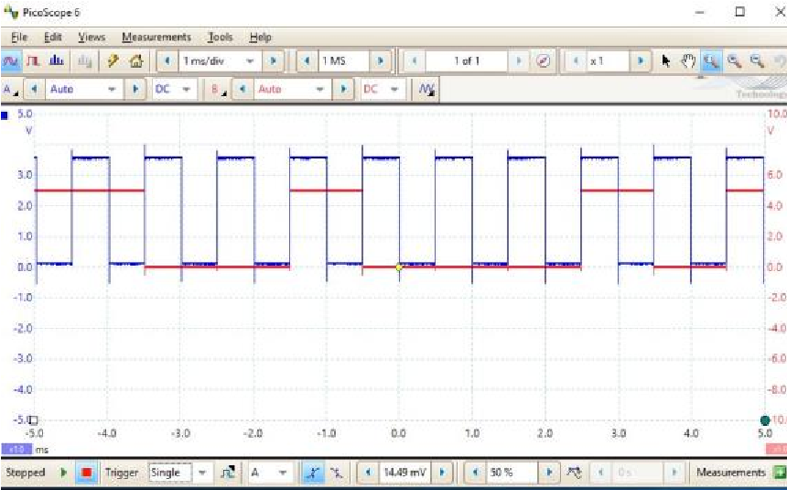

1. On the PicoScope, turn ChB on to Auto.

* Change the time base to 1ms/div for a better view of this digital signal.
* Employ single shot triggering. See Figure 7b.

5. Now employ the zoom and cursor features to read the briefest interval between consecutive transitions of the digital signal.

• Click on the green arrow to the left of the trigger to repeat the single shot triggering. Repeat this several times to ensure you are seeing a briefest transition.

Record the minimum interval of the digital signal here:

*997.0 µs*

Question: How does this interval compare to the clock cycle duration?

*It looks to be exactly one clock cycle*

Convert the displayed portion of the digital signal to a binary code: 0001010111

______________________________

# A.3 – BASEBAND CHANNEL FILTERS

This module allows users to select from 4 channels. Channel 1 is simply a through connection, while channels 2, 3, and 4 are different low pass filters. These are abbreviated as BBLPF2, BBLPF3, and BBLPF4 (for BaseBand Low Pass Filter 2, etc.). The module description in the appendix provides insight into these filters.

In the current experiment, the filters represent response time limitations (i.e. the “system inertia” metaphor). We will examine the digital signal just before and just after the filter section.

1. Insert the BASEBAND CHANNEL FILTERS

Fig 8 BASEBAND CHANNNEL FILTERS module is

shown inserted into Slot 6.

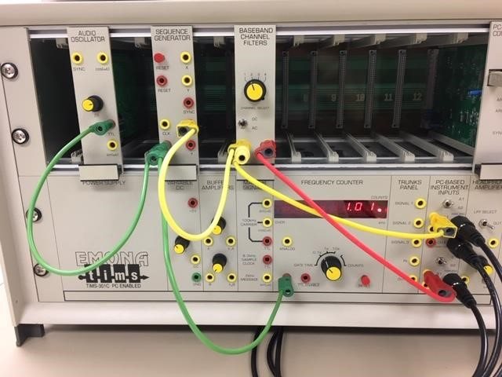

module into the TIMS rack (shown here in slot 6 of

Figure 8)

1. Connect the modules as shown in Figure 8.

* It may be easiest to remove the connections from the previous experiment and start fresh.
* Connect the AUDIO OSCILLATOR TTL clock signal to:
  + the SEQUENCE GENERATOR’s red clock input

(green lead)

* + the FREQUENCY COUNTER (green lead)
* Connect the SEQUENCE GENERATOR’s TTL clock output to the BASEBAND CHANNEL FILTERS input, and to Scope ChA (yellow leads).
* Connect the Baseband Channel Filters OUT to Scope Ch B (red lead).
* Select Channel 2 on the BASEBAND CHANNEL FILTERS module.

3. Adjust the PicoScope as follows:

Fig 9

Typical

digital signal

before and

after passing through

BBLPF2.

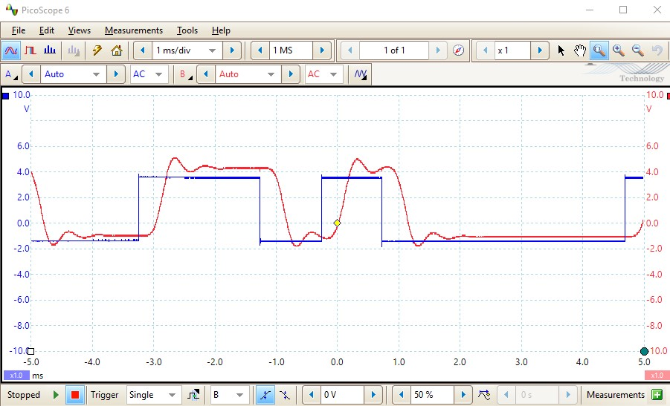

* Set the time scale to 1ms/div
* Employ AC coupling on Channel A
* Turn on channel B, with scaling set to

+/-5V

* Employ AC coupling on Channel B

4. View several single shot trigger events. Figure 9 shows one such event.

Fig 10

Delay and rise times

for a digital signal transit

ion from low to high.

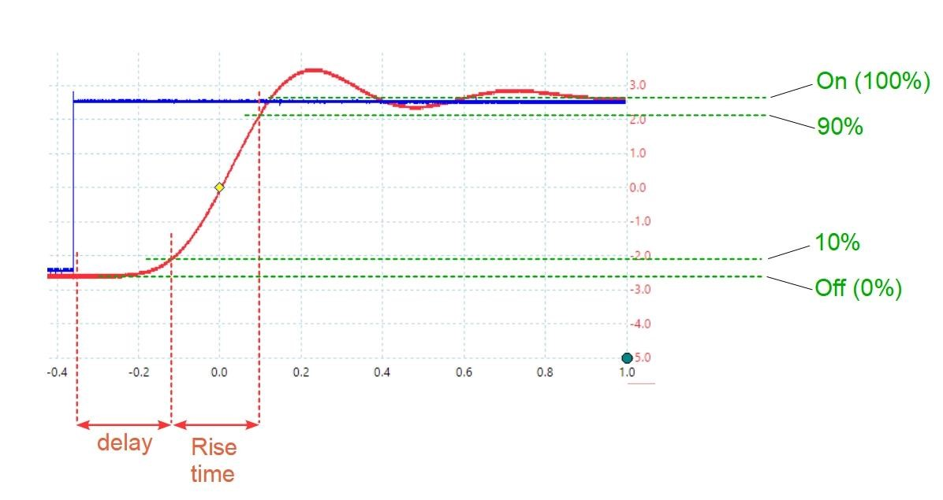

# Measuring Transition Time

When an actual digital signal transitions from a low state to a high state (or from a high state to a low state) it cannot do so instantly. There is a rise time associated with how long it takes to go from the low state (a digital logic “zero”) to the high state (a digital logic “one”). Likewise, there is a fall time associated with going from the high to the low state. Together, rise time and fall time are referred to as “transition times”.

Figure 10 indicates that rise time is measured from the time where the signal rises 10% of its transition time above the low state floor until it gets to 90% of its transition to the final voltage after the signal steadies out. Fall time is measured in a similar way. The figure also shows delay introduced to the signal by the system.

1. Use what you’ve learned so far to measure the delay and the rise and fall times of the digital signal passing through different filters. After making measurements at 1kHz, change the clock frequency to 1.5kHz and re-measure the rise and fall times.

Table 1: Delay and Transition Times for Sequence Data

|  |  |  |  |  |  |  |
| --- | --- | --- | --- | --- | --- | --- |
|  | BBLPF2 | | BBLPF3 | | BBLPF4 | |
|  | 1 kHz | 1.5 kHz | 1 kHz | 1.5 kHz | 1 kHz | 1.5 kHz |
| Delay | 238.6 µs | 250.9 µs | 238.8 µs | 195.2 µs | 834.3 µs | 830.8 µs |
| Rise time (10%-90%) | 233.6 µs | 209.7 µs | 212.9µs | 266.6µs | 183.9 | 182.5 µs |
| Fall time  (90%-10%) | 201.8 µs | 251.3 | 199.0 µs | 260.6 µs | 183.4µs | 182.8 µs |

1. Figure 13(a) and (b) shows some typical results of the delay and distortion introduced by the low pass filter system.

(

a

)

(

b

)

(

c

)

Fig 13 Typical scans to

compare the digital

signal just before and just after th

e filter

section at (a) 1 kHz, (b) 1.5 kHz, (c) 2.0 kHz

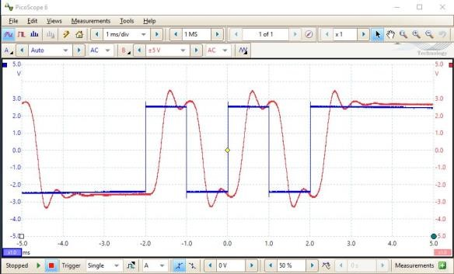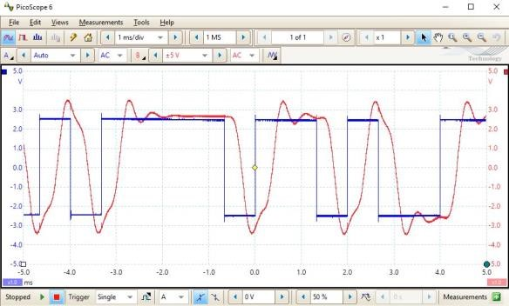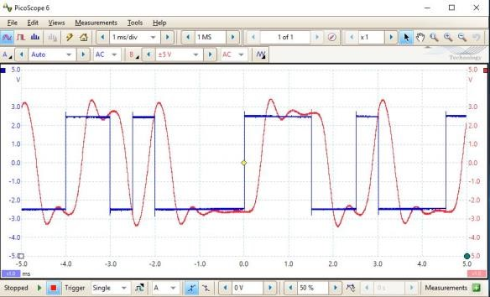

1. Increase f on the Audio Oscillator until the frequency counter reads 2.0 kHz. Observe the output (see Figure 13c).

1. Continue increasing f. At what frequency are you no longer able to accurately discern the digital signal?

f)max = 3kHz

# Part B – Step Input

A common approach to characterize system delay and response is to employ a step function input. In this experiment, we will simulate the step function by viewing the initial response to a long duration pulse.

(

a

)

(

b

)

Fig 15

(

a) o

utput without zoom, (c) output

with zoom appears as a step input and step

response.

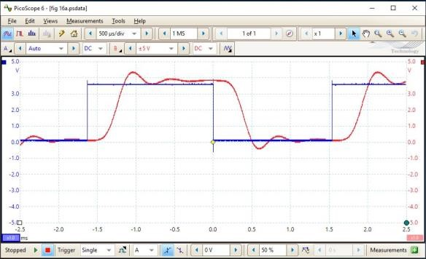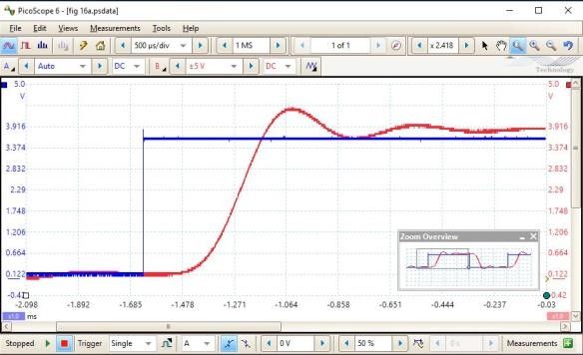

Fig 14

(

a) configuration to simulate a step

input.

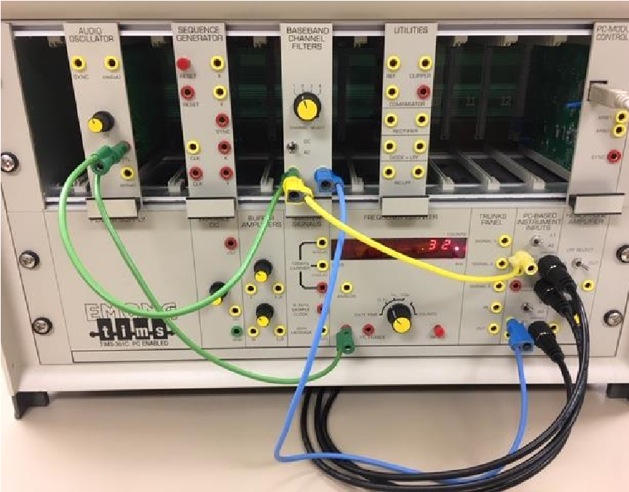

1. Connect the AUDIO OSCILLATOR output to the

FREQUENCY COUNTER input and to the BASEBAND CHANNEL FILTERS input, as shown in

Figure 14 (green leads).

* Connect Scope ChA to the input of the BASEBAND CHANNEL FILTERS input (yellow leads).
* Connect Scope ChB to the BASEBAND CHANNEL FILTERS output (blue lead).
* Adjust the f setting on the AUDIO OSCILLATOR to a low setting (fully counter clockwise is okay).
* Set the selection knob to Channel 2 for the

BASEBAND CHANNEL FILTERS (BBLPF2).

2. Now view the input and output signals on the PicoScope. With f set low, you should see only one or two pulses.

* Set the time scale to 500us/div, the output for Channel B to +/- 5V DC coupling, and the Trigger to Single. Press the green arrow to the left of the Trigger to view several scans, for instance like Figure 15a.
* Zoom in on a portion of the output signal as in Figure 15b. This will appear to be a step input signal plus system response to the step.

*When the response to a step excitation is isolated in this way, so that there is no overlap with the responses of neighboring transitions, it is called the step response.*

*Notice the presence of oscillations and the relatively long settling time to the final value. This is known as ringing; a term that goes back to the days of manual telegraphy and Morse code.*

3. Measure the system delay time. Refer to Figure 10.

• Find the time at the 10% point of the response, and subtract the time at the start of the step. • Record the result in Table 2.

1. Measure the rise time. Refer to Figure 10. • Record the result in Table 2.

1. Fill in the remainder of Table 2.

Table 2: Step Response for Various Filter Systems (low f setting)

|  |  |  |  |
| --- | --- | --- | --- |
|  | BBLPF2 | BBLPF3 | BBLPF4 |
| **Delay time** | 238.9 µs | 266.3 µs | 821.8 µs |
| **Rise time** | 210.3 µs | 299.4 | 212.0 µs |

(

a

)

(

b) (c

)

Fig. 16: (a) impulse function, (b) delayed impu

lse function, (c) model of impulse function.

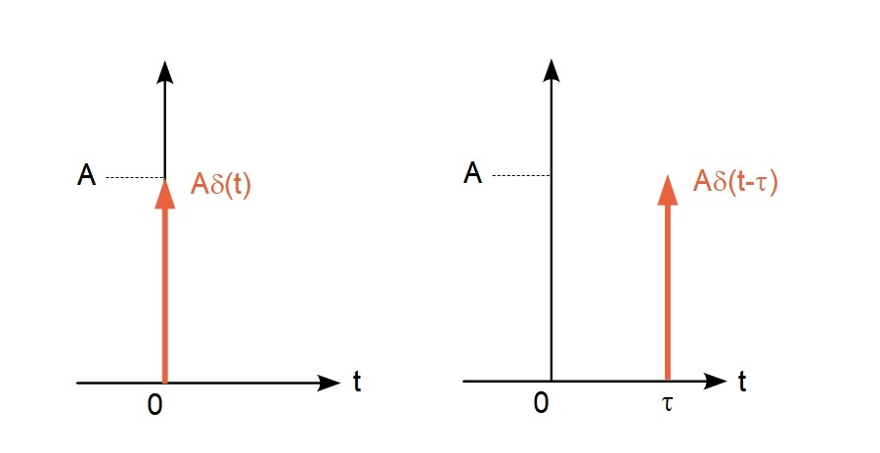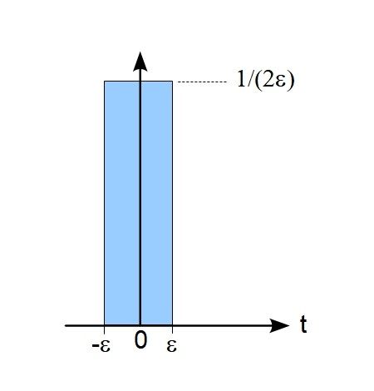

# Part C – Impulse

An ideal impulse function is shown in Figure 16a. As has likely been explained in lecture, the impulse function is a useful tool to express derivatives at discontinuities and for use in the sifting function. A system’s response to an impulse function (i.e. the “impulse response”) is very useful for linear time invariant systems. For LTI systems, any input signal can be expressed as a train of impulse functions. The system response to the signal is then simply the sum of the responses for the impulse train.

Mathematically, we can treat the impulse as a short duration pulse as shown in Figure 16c. For a unit impulse duration 2, the pulse has a height 1/(2  and thus unity area. For the ideal impulse,  approaches zero. In our TIMS equipment experiment, we will approximate an impulse function with a short duration rectangular pulse, with the caveat that the height of the pulse will be system limited. Thus, our impulse signals will have an area less than 1, tantamount to feeding less power to the system. Consider a response in voltage vs time in Figure 17. The system’s impulse response will have the same shape as that for an ideal impulse input, but will be compressed in voltage.

Fig 17 (a) system response to an ideal impulse input. (b) same

system’s response for a limited impulse input.

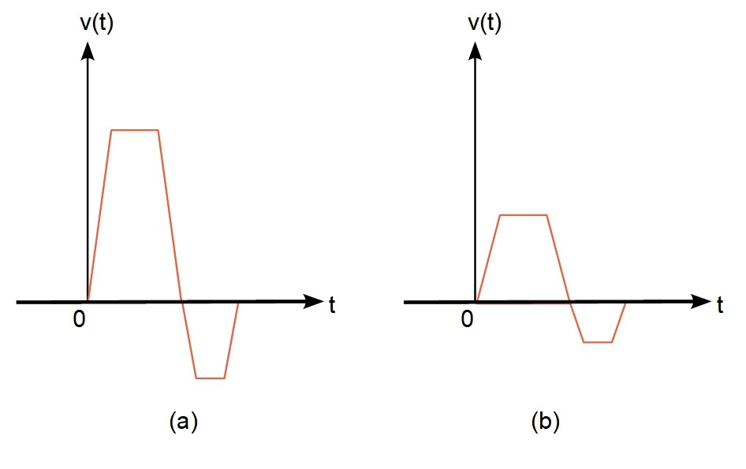

1. In order for the following instructions to match what you will be seeing, it is convenient to start fresh.

(

a

)

(

b

)

Fig 18

(

a) configuration to simulate an impulse. (b) the

generated rectangular pulse.

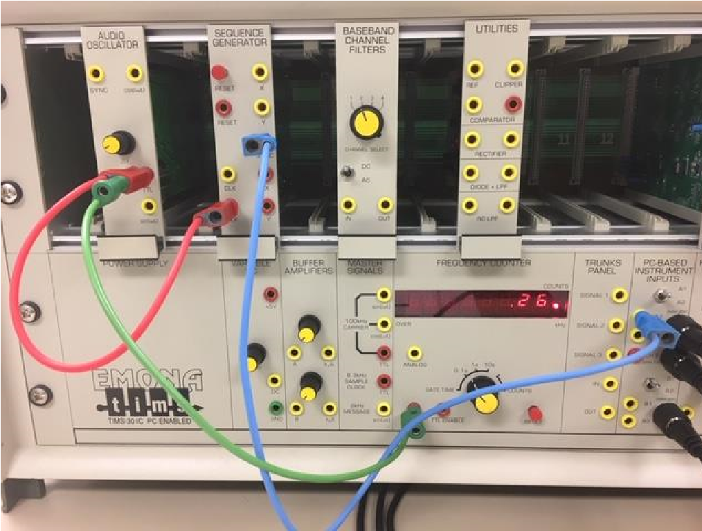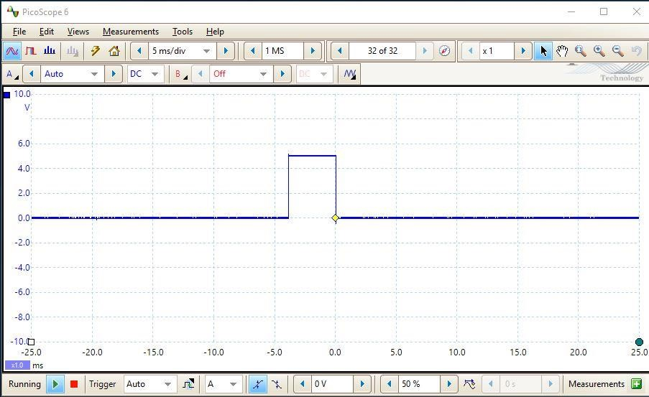

• Disconnect all leads and turn off the PicoScope.

2. The SEQUENCE GENERATOR’s SYNC

output will provide us with something similar to a single rectangular pulse signal.

* Connect the AUDIO OSCILLATOR TTL LEVEL OUTPUT to the SEQUENCE

GENERATOR’s TTL CLOCK input, and to the

FREQUENCY COUNTER’s TTL input. See

Figure 18a.

* Connect the SEQUENCE GENERATOR’s SYNC output to Scope ChA.
* Turn f fully counterclockwise on the AUDIO OSCILLATOR.

3. Turn on the PicoScope.

* Set ChA to DC coupling
* Set the Trigger to AUTO. See Figure 18b.

4. Investigate the relationship between frequency and pulse width.

* Set f close to 0.5 kHz and measure the width of the pulse. Record in Table 3 and place the point on the blank graph of Figure 19.
* Repeat this process for the f values shown to complete Table 3 and Figure 18. You may wish to decrease the time scale to 1ms/div, and/or employ zoom in the vicinity of the pulse.

Table 3 – Pulse Width Data

|  |  |
| --- | --- |
| f (cycles per second) | Pulse Width (us) |
| 500 | 1.926 ms |
| 1000 | 983.6 µs |
| 1500 | 660.0 µs |
| 2000 | 478.4 µs |
| 3000 | 322.1 µs |
| 4000 | 231.4 µs |
| 6000 | 154.8 µs |
| 8000 | 103.7 µs |
| 10,000 | 86.64 µs |

Fig 19

Relation between frequency and pulse width

0

500

1000

1500

2000

2500

0

1000

2000

3000

4000

5000

6000

7000

8000

9000

10000

Pulse Width (us)

frequency (cycles per second)

1. Connect the SEQUENCE GENERATOR Sync output to the BASEBAND CHANNEL FILTERS input, and the BASEBAND

Fig 20

Configuration to view simulated impulse response.

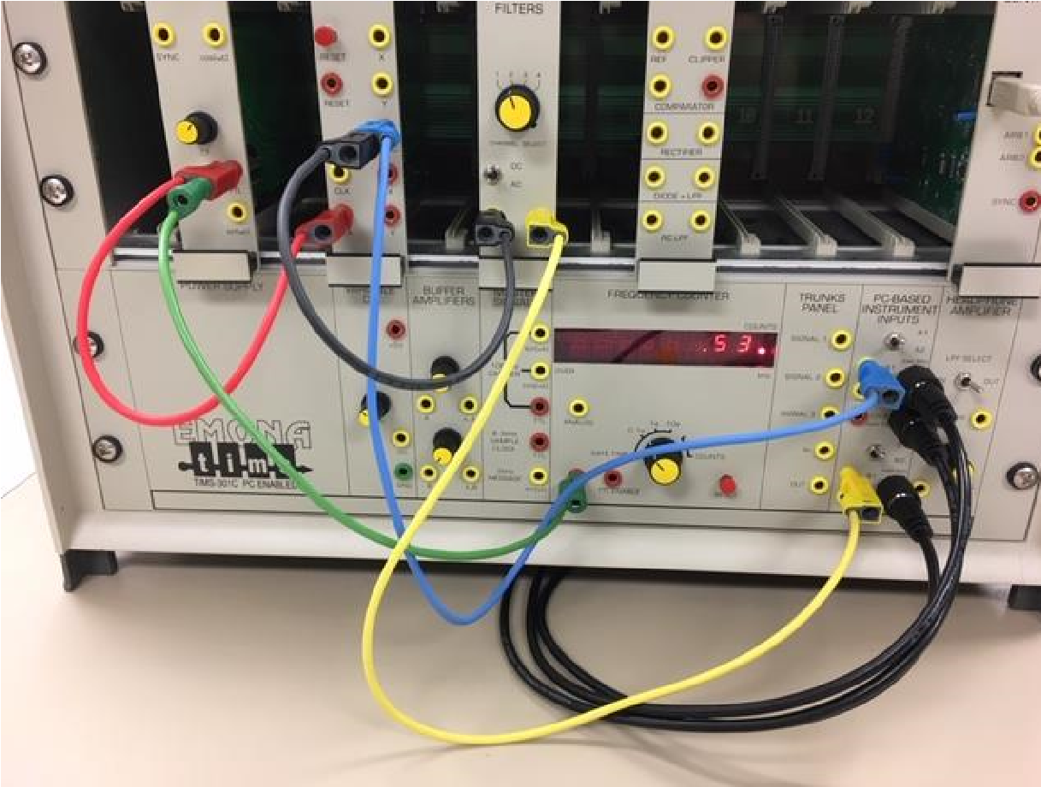

CHANNEL FILTERS output to Scope ChB. See Figure 20.

1. On the PicoScope, turn on Ch B with DC coupling and +/- 10V.

Fig 21

BBLPF2 response compared with input at 300 Hz.

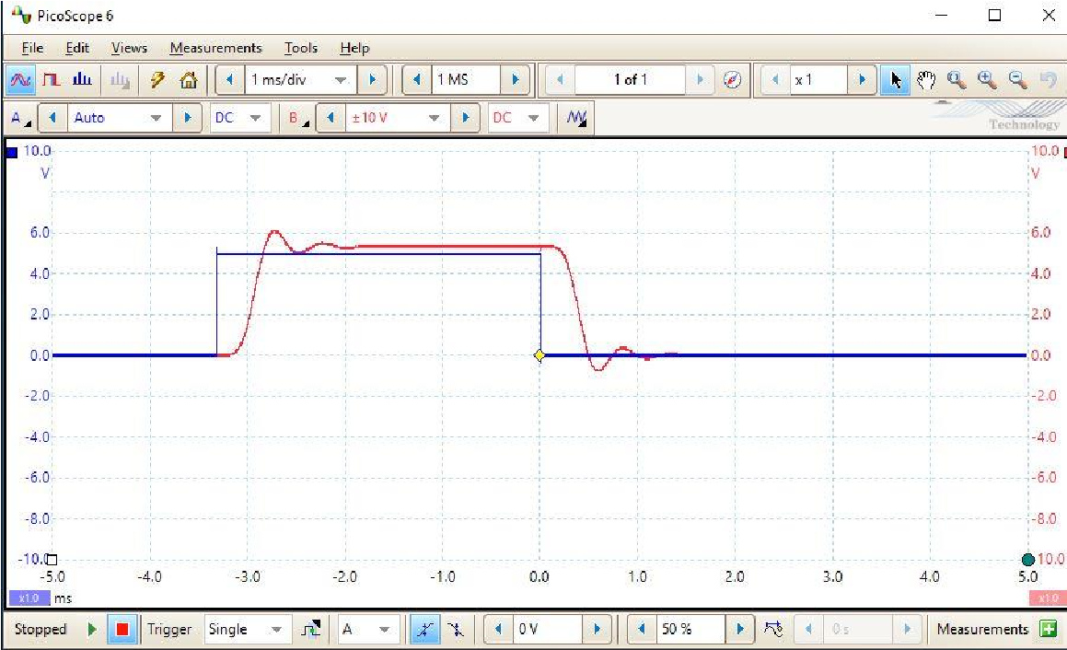

* Set AUDIO OSCILLATOR f to 300 Hz.
* See Figure 21.

7. Observe the response as you slowly increase f to 1000 Hz. See Figure 22.

Fig 22

BBLPF2 response compared with input at 1000 Hz.

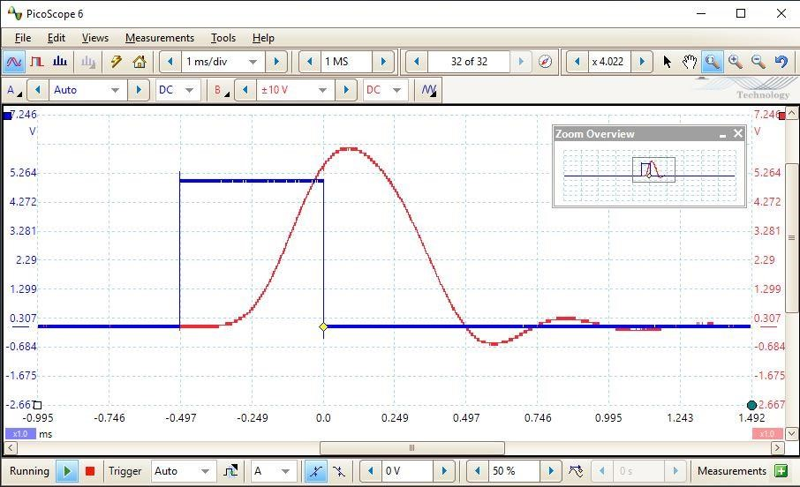

• Note that the transitions are not affected, but as you continue to increase the frequency, and thus reduce the impulse width, the flat top between transitions gets shorter, and ultimately disappears.

STOPED

(

a

)

(

b

)

Fig 23

Input and BBLPF2 response for

(

a)



f = 2000; (b)



f = 10,

000

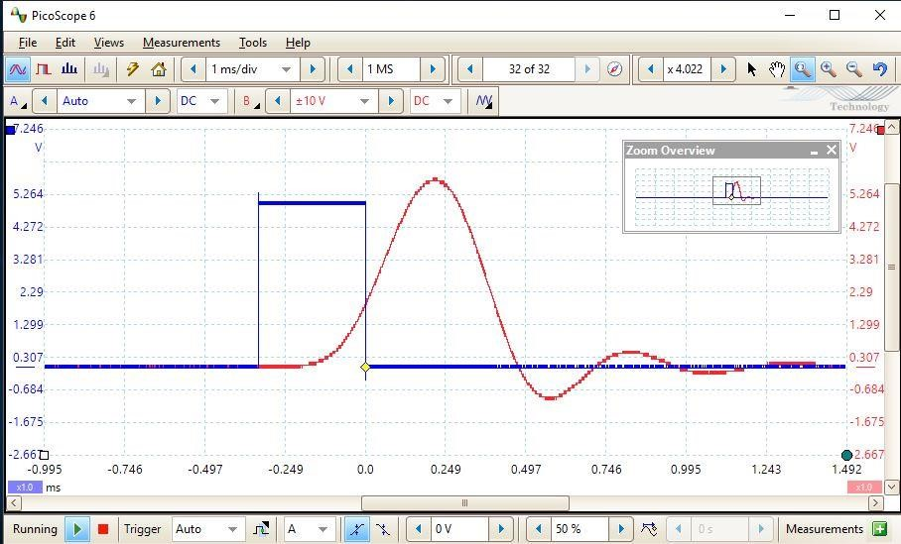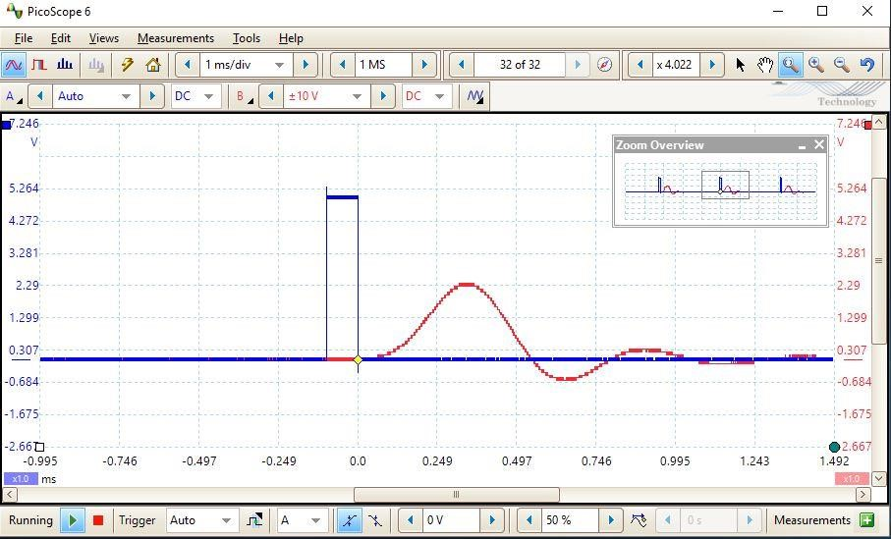

1. Increase f to 2000 Hz. See Figure 23(a).

1. Slowly increase f from 2000 to 10,000 Hz while observing the response. See Figure 23(b) for the response at 10,000 Hz.

*Notice that when the pulse width becomes short enough, the general shape of the output (ignoring the amplitude) no longer changes. This is the impulse response for the system.*

Q: Why does the amplitude change with continued decrease in pulse width?

The filtered signal doesn’t have enough time to rise to its peak voltage before the falling edge of

the un-filtered signal, so it falls back down.

# Part D – Sinusoidal Signals

This section will focus on sinusoidal signals (i.e. sine waves). Why are sine waves important now in the digital age? One reason is that wireless communication systems transmit information by modulating sine waves. Also, the study of Fourier Series reveals that the spectrum of pulses is a collection of sine waves. So, the topic of sinusoidal signals remains of critical importance for electrical, computer, and wireless engineers.

# D.1 – Basic Sine Waves

1. In order for the following instructions to match what you will be seeing, it is convenient to start fresh.

• Disconnect all leads and turn off the PicoScope.

2. Connect the AUDIO OSCILLATOR sin(t) output to the BUFFER AMPLIFIER input A. See Figure 24 (black lead)

Fig 2

4

Configuration to view sinusoidal signals

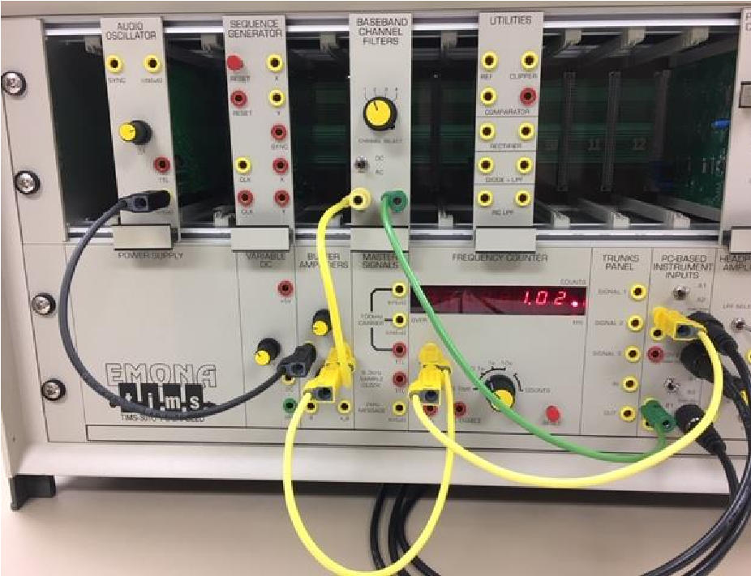

• The BUFFER AMPLIFIER will allow control of the sinusoidal amplitude.

3. Connect the BUFFER AMPLIFIER output k1A to the FREQUENCY COUNTER, THE BASEBAND CHANNEL FILTERS input, and the Scope ChA. See Figure 24 (yellow leads)

* Adjust the AUDIO OSCILLATOR frequency to 300 Hz.
* Set BASEBAND CHANNEL FILTERS to Channel 2 (BBLPF2).

4. Connect the BASEBAND CHANNEL FILTERS output to Scope ChB.

Fig 25 Input and output for the BBLPF2. The gain

i

s

set to provide

a

6

Vpp input sinusoid.

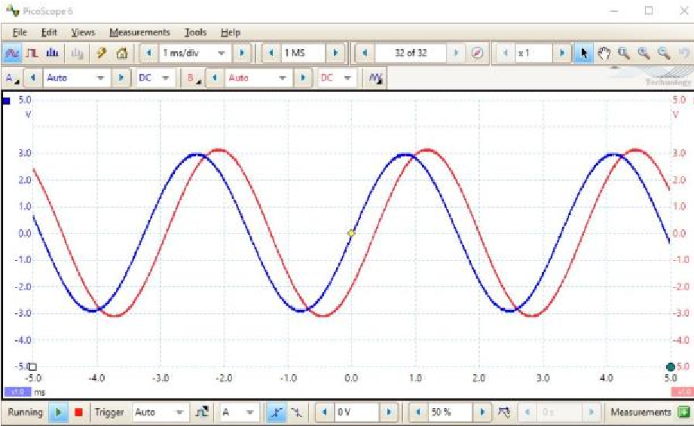

• See Figure 24, green lead.

5. Open the PicoScope

* Set timescale to 1ms/div and Trigger to Auto
* Turn on Channel B. Start with Auto Scale, but often you may need to adjust the scale.
* Adjust the BUFFER AMPLIFIER gain, knob k1, to achieve a 6 Vpp (“6 volts peak-to-peak”) input signal.
* See Figure 25

1. Read the output signal Vpp and record its value in Table 4.

Fig 26 The output at 4 kHz is getting noisy.

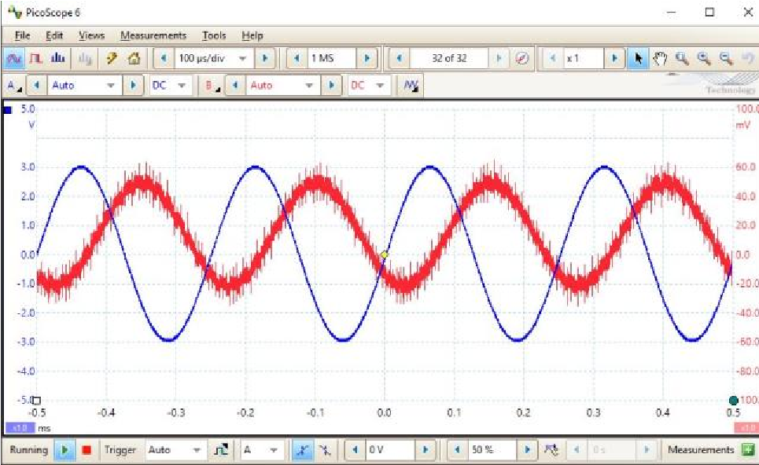

1. Fill in the rest of Table 4 by adjusting the sinusoid’s frequency and amplitude

* Maintain a constant 6 Vpp input signal.
* Adjust time scale as needed to view several cycles of the sinusoid
* Comment below on the signal quality. Note that Figure 26 shows the results at 4 kHz. Given the noisy nature of the signal, it will be hard to measure Vpp precisely. A good approach is to measure from the center of the fuzzy trace.

Comments on Signal Quality:

The signal quality gets worse as you increase the frequency

Table 4

|  |  |  |  |
| --- | --- | --- | --- |
| Frequency Hz | BBLPF2 Vpp | BBLPF3 Vpp | BBLPF4 Vpp |
| 300 | 6.4 V | 6 V | 6.42 V |
| 1000 | 6.4 V | 4.823 V | 6.97 V |
| 2000 | 6.4 V | 1.85 V | 5.32 V |
| 3000 | 526 mV | 438.2 mV | 33 mV |
| 4000 | 100 mV | 122 mV | 175.3 mV |
| 5000 | 88 mV | 87.65 mV | 175.2 mV |

# D.2 – Clipping

We will now use the UTILITIES module and show how the CLIPPER BIPOLAR OUTPUT

(or CLIPPER for short) can convert a sine wave to a square wave.

1. In order for the following instructions to match what you will be seeing, it is convenient to start fresh.

• Disconnect all leads and turn off the PicoScope.

2. Connect the circuit as shown in Figure 27.

* Connect the AUDIO OSCILLATOR sin(t) output to the BUFFER AMPLIFIER input (black lead).
* Connect the BUFFER AMPLIFIER’s

ANALOG OUTPUT to the FREQUENCY COUNTER, the UTILITIES module’s ANALOG SIGNAL INPUT, and Scope ChA (yellow leads).

Fig 27

Configuration to study clipping.

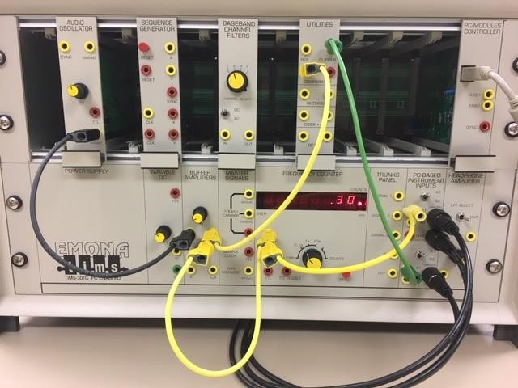

(

a

)

(

b

)

Fig 28 (a) Clipped output for 6Vpp sinewave input.

(

b) output for weak input signal.

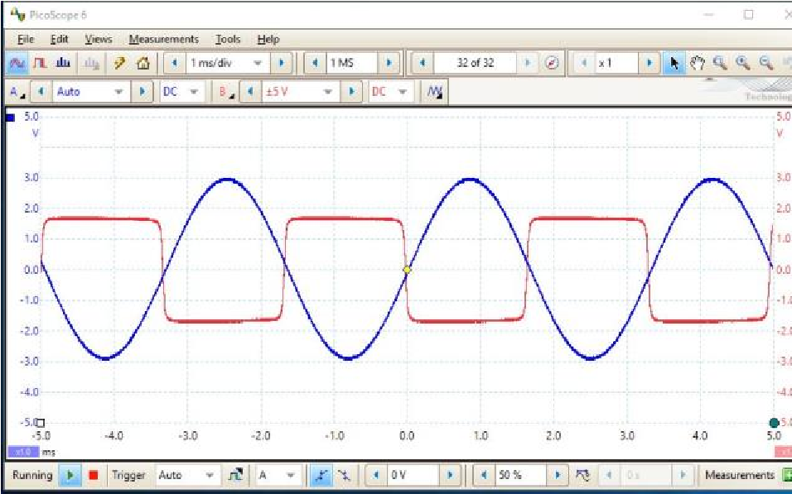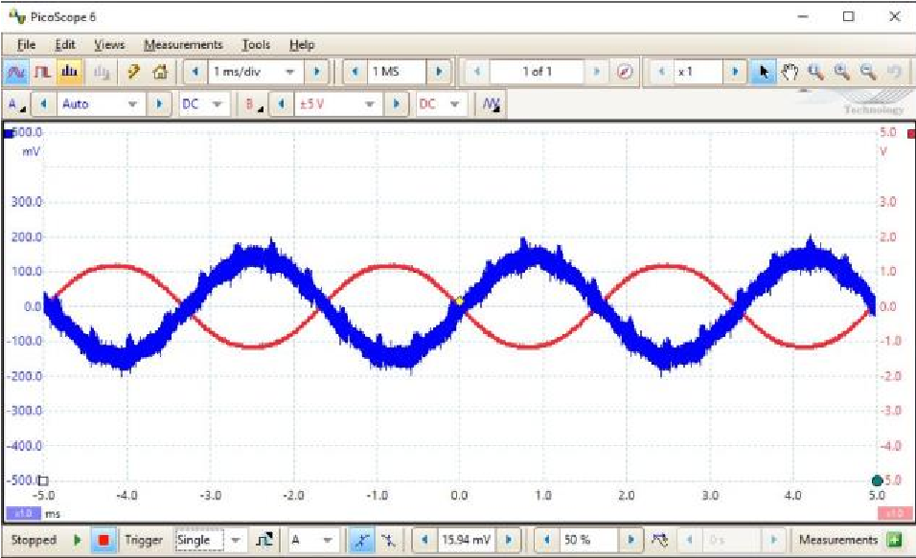

* Connect the CLIPPER to Scope ChB (green lead).

3. PicoScope setup

• Timescale 1ms/div; set ChA trigger to Auto • Adjust BUFFER AMPLIFIER k1 to achieve 6Vpp.

1. On the PicoScope, turn on ChB – set to the same scale as ChA. See Figure 28a.

1. Adjust the BUFFER AMPLIFIER k1 to decrease the input signal to a Vpp of approximately 300 to 350 mV.

* On the PicoScope, use Single Shot Triggering.
* See Figure 28b.
* How has the output signal changed?

the output signal has less noise and it’s the inverse of the input signal.

6. Slowly increase the signal amplitude to 20 Vpp.

Comment on the change to the output signal.

Changes closely to a square wave (looks similar to a clock

*The signal to the Comparator must be strong enough to engage the Clipper.*

# E: – Digital Detector

A digital signal passing through a system (for instance, the BBLPF2) will suffer signal degradation. Then, provided the degradation is not too severe, a digital detector can recover the original signal. The ability to recover the signal despite degradation is a key advantage for digital systems.

1. In order for the following instructions to match what you will be seeing, it is convenient to start fresh.

• Disconnect all leads and turn off the PicoScope.

2. Connect the circuit as shown in Figure 29

* Connect the AUDIO OSCILLATOR sin(t) output to the input of the SEQUENCE

GENERATOR, and to the FREQUENCY

COUNTER (green leads) • Connect the SEQUENCE GENERATOR’s AUDIO OUTPUT to the BASEBAND

CHANNELS FILTER input, and to Scope ChA

Fig 29

Initial digital d

etector configuration.

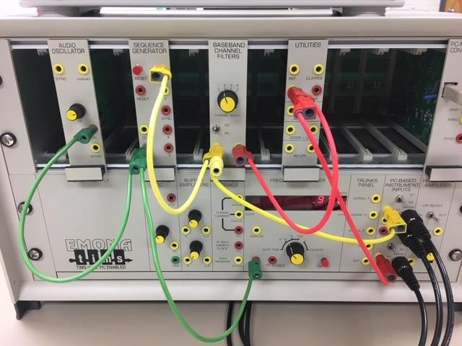

(

a

)

(

b

)

Fig 30 (a) The output of the filter is compared to

the input digital signal. (b) the clipper output (i

.e.

the digital detector output)

is compared with the

input digital signal.

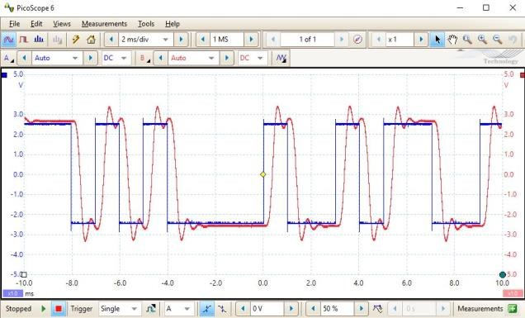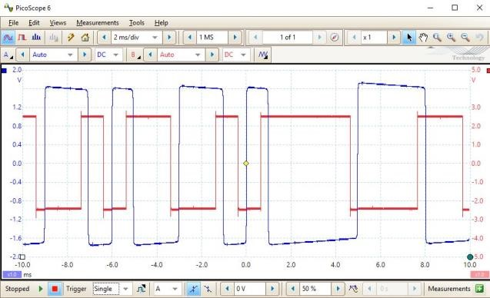

(yellow leads)

* Connect the BASEBAND CHANNELS FILTER output to the UTILITIES module ANALOG SIGNAL INPUT and to Scope ChB. (red leads)

3. Open the PicoScope and set it up as follows:

* Set timescale to 2ms/div
* Turn on ChB (to Auto) • Select Single Shot Triggering
* See Figure 30a.

4. Disconnect Scope ChB from the BASEBAND CHANNELS FILTER output. Connect the UTILITIES module CLIPPER to Scope ChB.

* See Figure 30b. *Note the delay and the inversion of the signal.*
* Observe that the digital signal is accurately recovered, but inverted.

|  |  |  |
| --- | --- | --- |
| f  (kHz) | Input digital signal | Output digital signal |
| 4 | 10110010111001101 | 10110010111001101 |
| 5 | 01110011011010100010 | 0111001101101010001 |
| 7 | 01101010001001011001011100110 | 01100100010011100111001 |

5. As the frequency is increased, the digital signal passing through the system (i.e. the BBLPF2) becomes more degraded. This will eventually lead to errors in the recovered digital signal.

(

a

)

4

kHz

(

b

)

5

kHz

(

c

)

7

kHz

Fig 31 Recovery of t

he digital signal for

increasing frequencies.

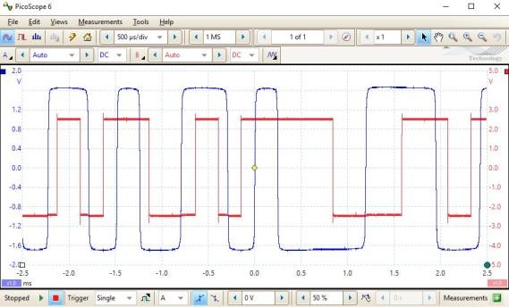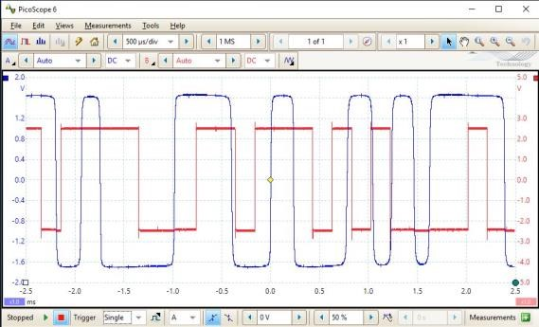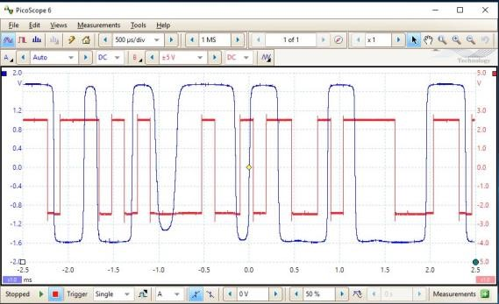

• Observe the input digital signal and the recovered digital signal as frequency is increased. See Figure 31 for several examples.

6. In Table 5, convert a convenient portion of your input and output signals to their digital equivalents

Table 5 Comparing recovered digital signal to original digital signal

**END OF LAB 2**

**Lab Review (Notes for future labs)**

I felt like the lab was a little long. I did not have time to finish the entire thing in class and if there was some way to condece the lab down more, or to have the ability to use the actual lab equipment outside of class hourse, I feel like this would be fine. The lab itself was well explained and not too difficult at all. The only thing I really had a problem with was the time. Maybe also add bold lettering or change the text color for all questions so that they are easier to see as well.